INSTALLATION – TASK
Install Docker:
  - To install docker in amazon – Linux ec2- machine command used is sudo yum install docker -y
  - It will install the latest docker version in our ec2-machine
  - Use this commands to start the docker
    - Systemctl start docker and systemctl status docker
  - To check the docker version use command docker -v
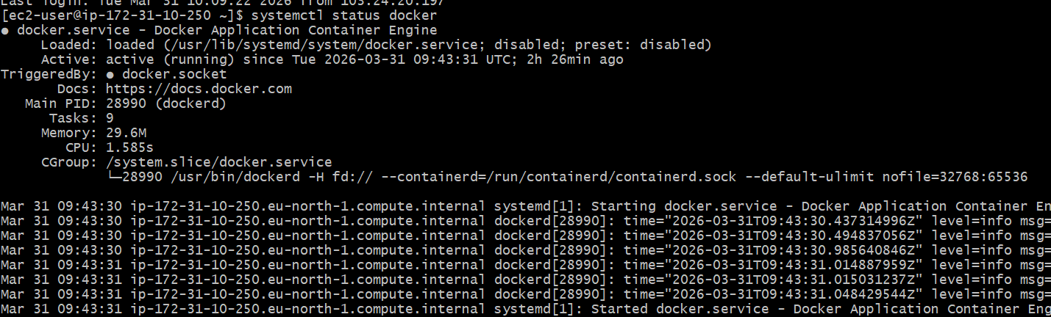

Install Jenkins :
- First we need to installjava before installing junkins..
- To install java using the command= sudo yum install java (install the latest version of java)..
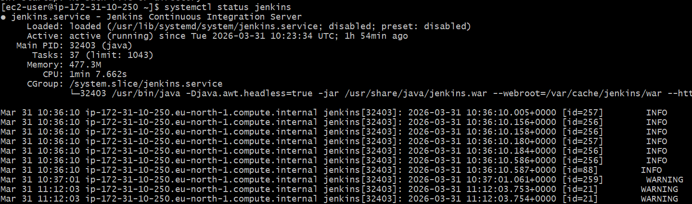

Now junkins is running in the port number 8080.

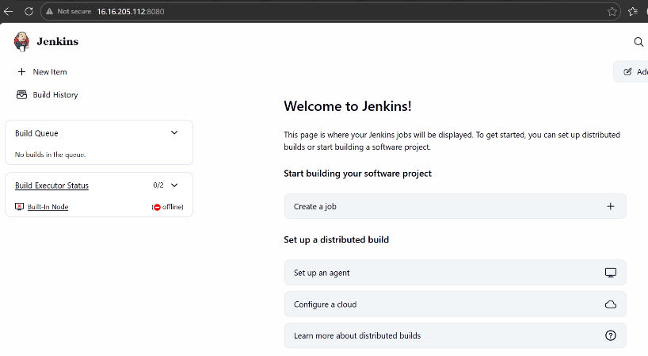

Install apache (httpd):

- To install httpd use this command = sudo yum install httpd
- It will install now start the service using command systemctl start httpd and systemctl status httpd
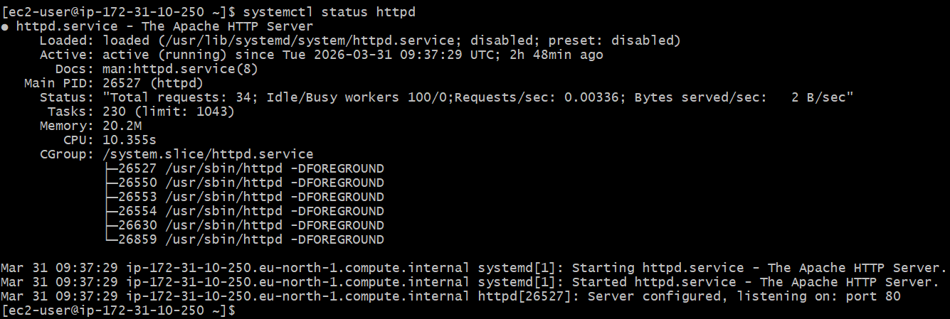
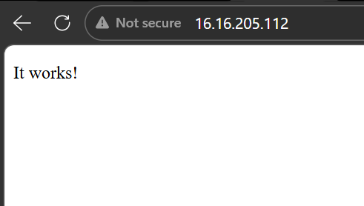

Now httpd works

Install Nginx:
  - To install nginx command = sudo yum install nginx
    - it will install now start the service using command = Systemctl start nginx and systemctl status nginx
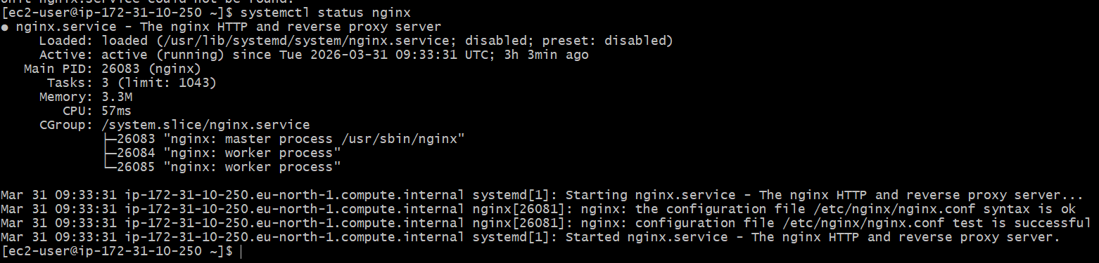
- Now nginx server is running
- Now since we are using apache and nginx since both are running in same port
  - Now we need to change the port by going to location command = nano /etc/nginx/nginx.conf
After changing the port nginx run on port 81
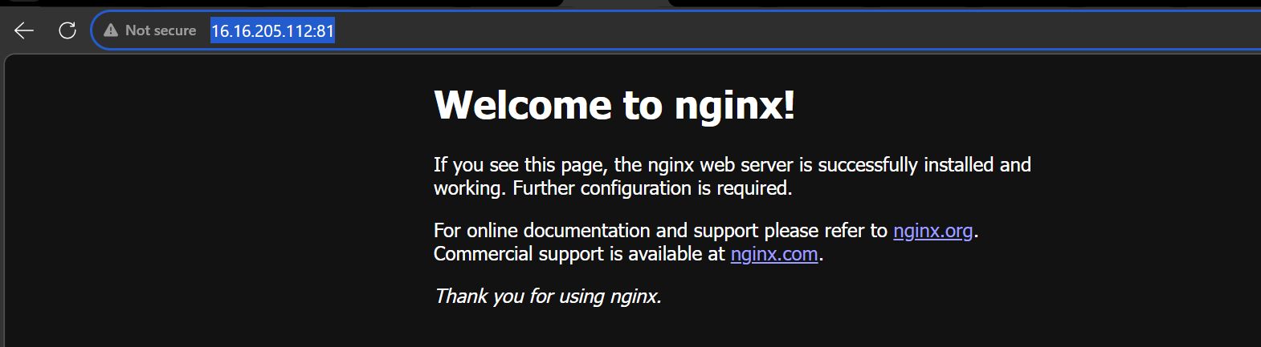
Install Tomcat:
- To use the following command
  - first use wget command to get download the package
  - wget https://dlcdn.apache.org/tomcat/tomcat-9/v9.0.116/bin/apache-tomcat- 9.0.116.tar.gz use the command to download tomcat
- Now tar xvf apache and go to bin and use sh startup,sh to run the tomcat
  - command so the server will start
- Since we are using Jenkins and tomcat on same server and port need to change the port
- number in tomcat using this location ..
- Go To tomcat cd conf nano server.xml and change the connector port to 8081
- Now since we changed the port number restart using command sh shutdown.sh and
- and start shutdown.sh
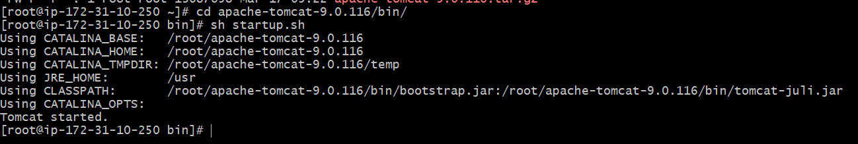
Tomcat server is now running on 8081

